Alex Yuille

8609035

CSI 3130 A

Beatrice Johnson

8198979

CSI 3530 A

A) Queries

To see SQL needed to create database please see attached document CreateDatabaseLines.

1. SELECT sname, age FROM Sailor

2. SELECT DISTINCT s.sname, s.age FROM sailor s

3. SELECT * FROM Sailor s WHERE s.rating > 7

4. SELECT s.sname

FROM sailor s

JOIN reserve r ON s.sid = r.sid

WHERE r.bid = 103

5. SELECT sname FROM Sailor s, Boat b, Reserve r WHERE s.sid=r.sid AND r.bid=b.bid AND color= 'red'

6. SELECT DISTINCT b.color

FROM boat b

JOIN reserve r ON b.bid = r.bid

JOIN sailor s ON s.sid = r.sid

WHERE s.sname = 'Lubber'

7. SELECT sname FROM Sailor s, Reserve r WHERE s.sid=r.sid

8.

SELECT s.sname, s.rating+1 AS rating

FROM Sailor s, reserve r1, reserve r2

WHERE s.sid = r1.sid AND s.sid = r2.sid AND r1.day = r2.day AND r1.bid <> r2.bid

9. SELECT age FROM Sailor s WHERE s.sname LIKE 'B_%b'

10.

SELECT DISTINCT s.sname

FROM Sailor s

JOIN reserve r ON r.sid = s.sid

JOIN boat b ON b.bid = r.bid

WHERE b.color = 'green' or b.color = 'red'

11. SELECT sname FROM Sailor s, Reserve r1, Boat b1, Reserve r2, Boat b2 WHERE s.sid = r1.sid AND r1.bid = b1.bid AND s.sid =r2.sid AND r2.bid = b2.bid AND b1.color='red' AND b2.color = 'green'

12.

SELECT s.sid

FROM Sailor s, Reserve r, Boat b

WHERE s.sid = r.sid and r.bid = b.bid and b.color = 'red'

EXCEPT

SELECT s2.sid

FROM Sailor s2, reserve r2, boat b2

WHERE s2.sid = r2.sid and r2.bid = b2.bid and b2.color = 'green'

13. SELECT sname FROM Sailor s, Reserve r WHERE s.rating =10 OR (s.sid = r.sid AND r.bid =104)

14.

SELECT avg(age) FROM Sailor;

15.SELECT avg(age)

FROM Sailor s

WHERE s.rating = 10

16.

SELECT s.sname, s.age

FROM Sailor s

WHERE age = (Select max(age) FROM Sailor)

17. SELECT count(sname) FROM Sailor

18.

SELECT count(DISTINCT sname) FROM Sailor

19. SELECT s.rating, MIN (s.age)  
FROM Sailor s  
GROUP BY s.rating

20.

SELECT s.rating, Min(s.age)

FROM Sailor s

WHERE s.age >= 18

GROUP BY s.rating

HAVING count (*) > 1

B) Query Evaluations

1.

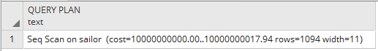

2.

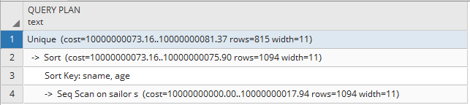

3.

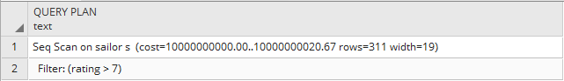

4.

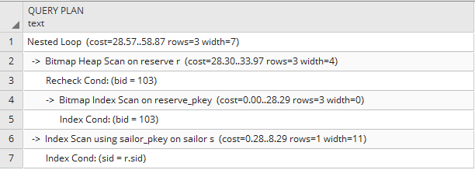

5.

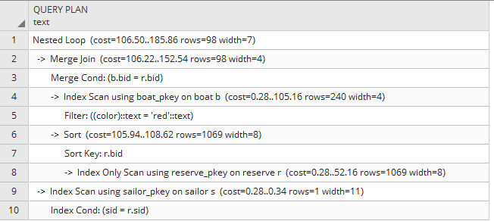

6.

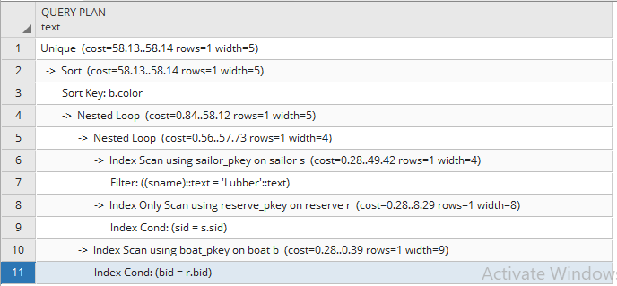

7.

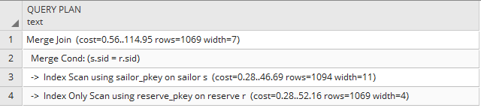

8.

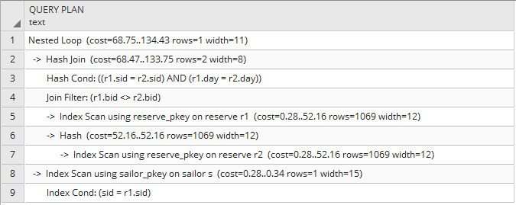

9.

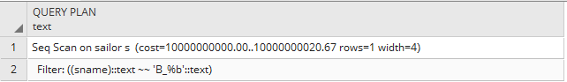

10.

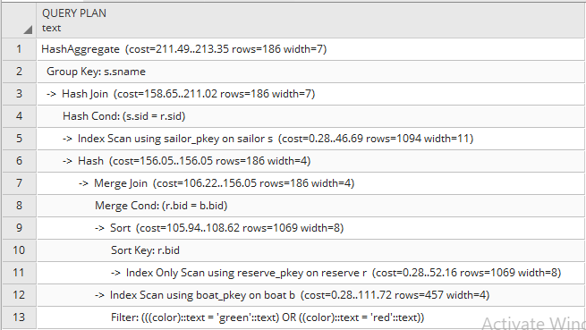

11.

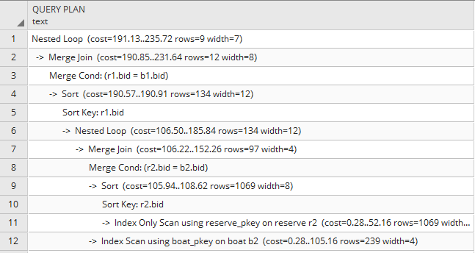

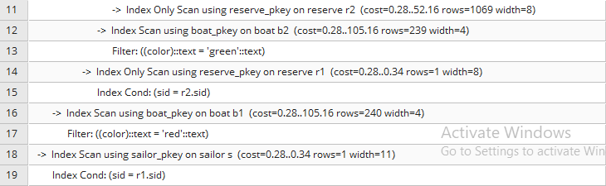

12.

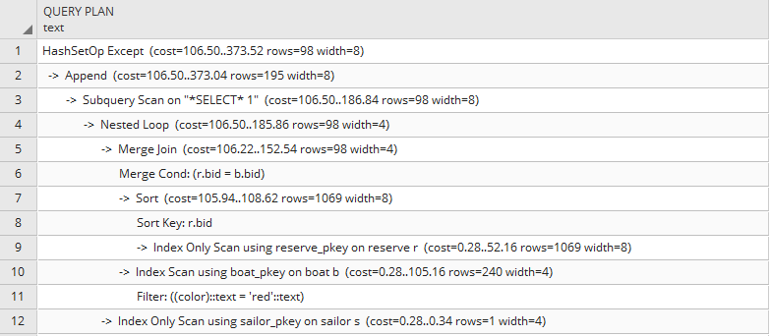

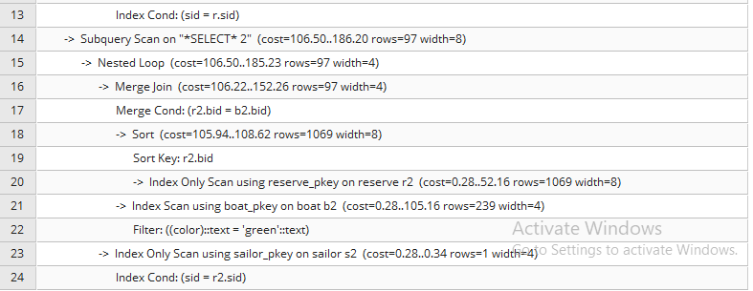

13.

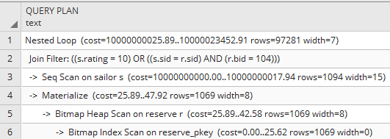

14.

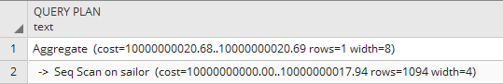

15.

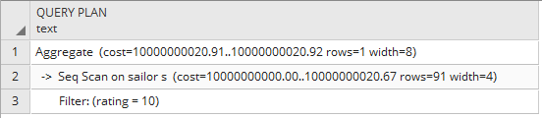

16.

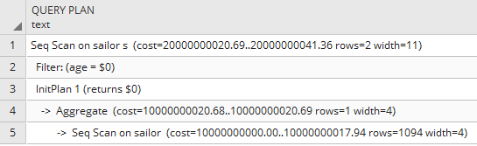

17.

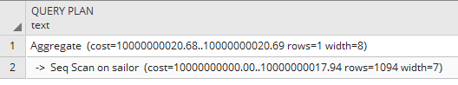

18.

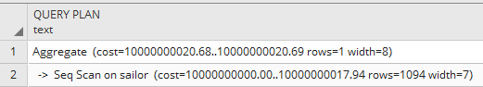

19.

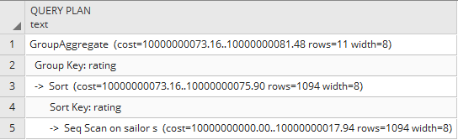

20.

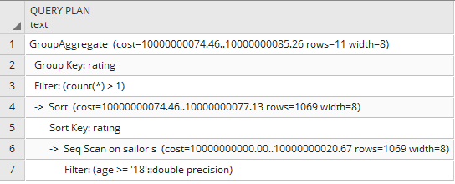

C) Access Paths and implementations

1.

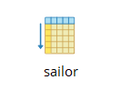

2.

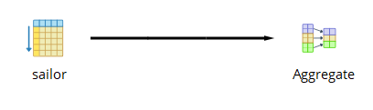

3.

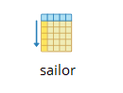

4.

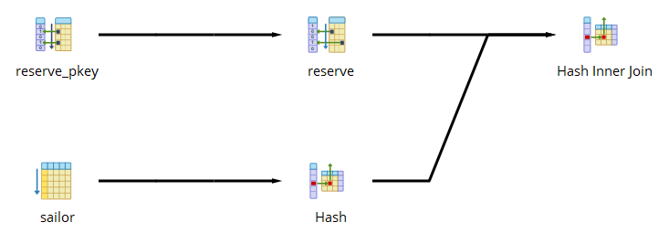

5.

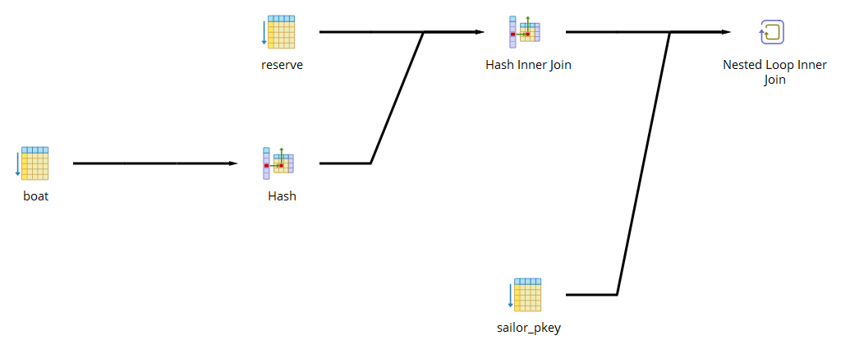

6.

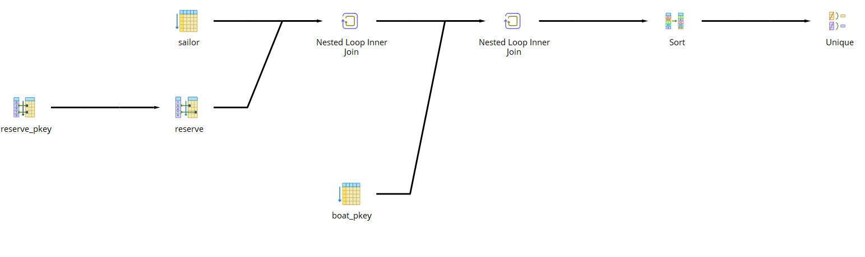

7.

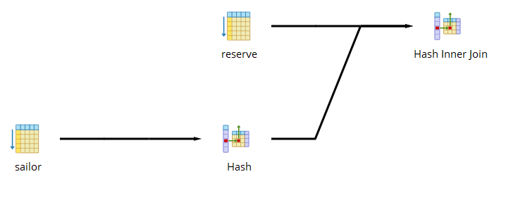

8.

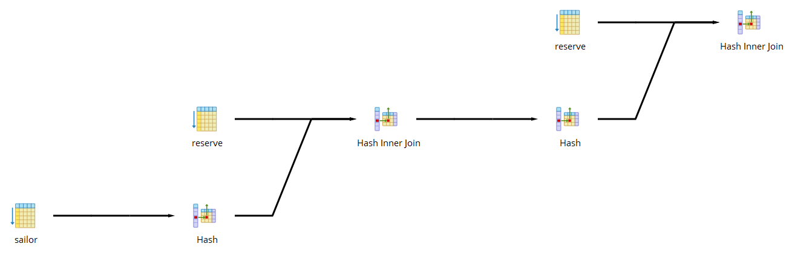

9.

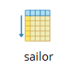

10.

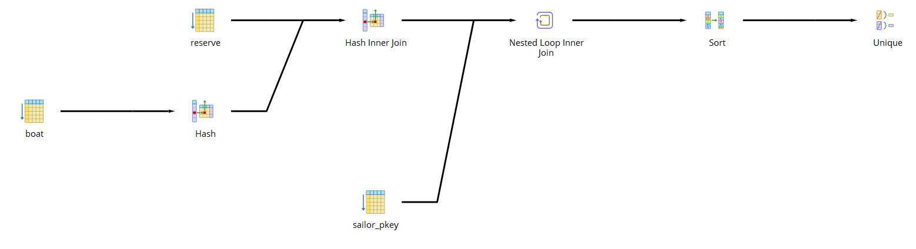

11.

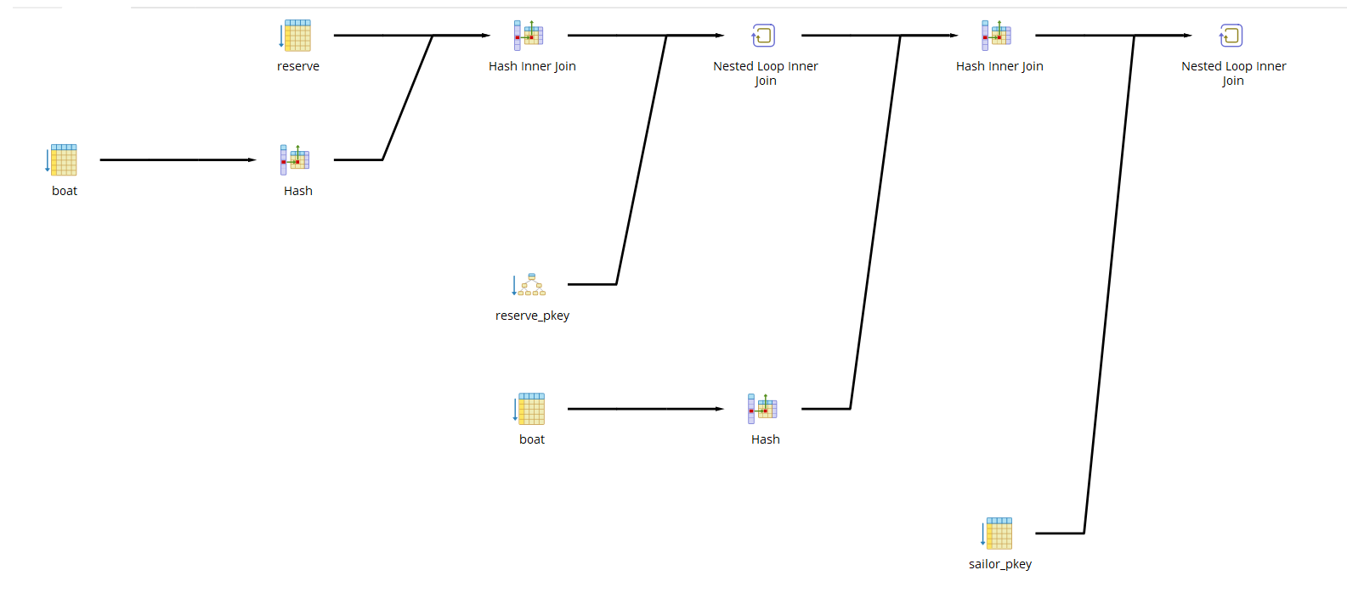

12.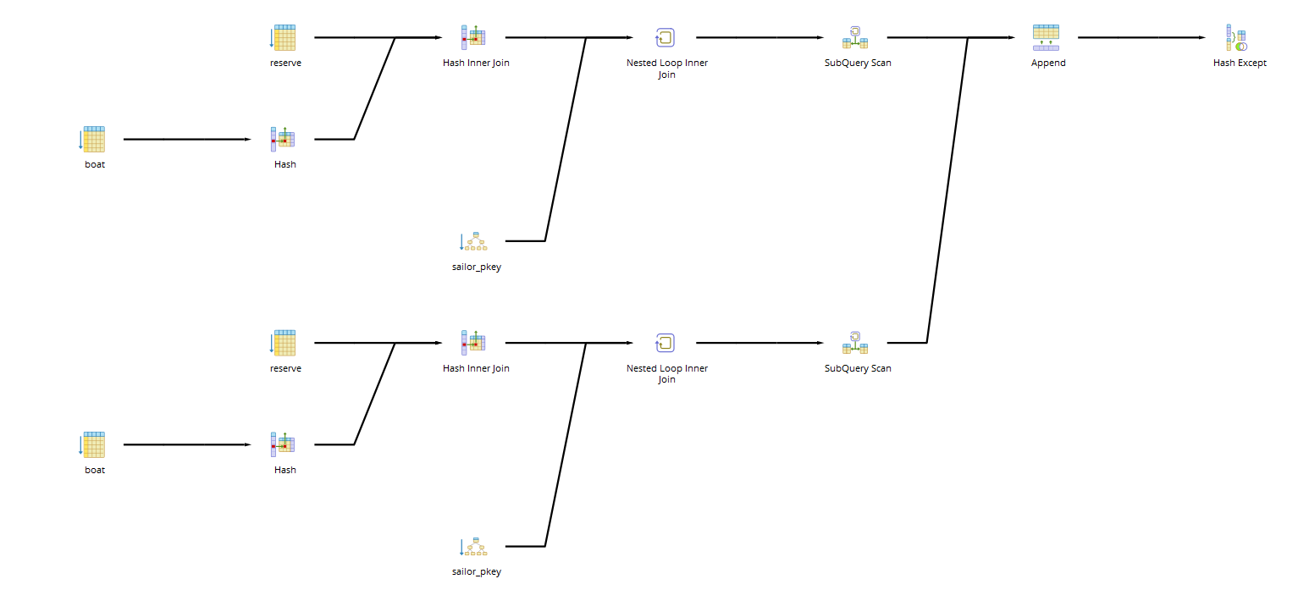

13.

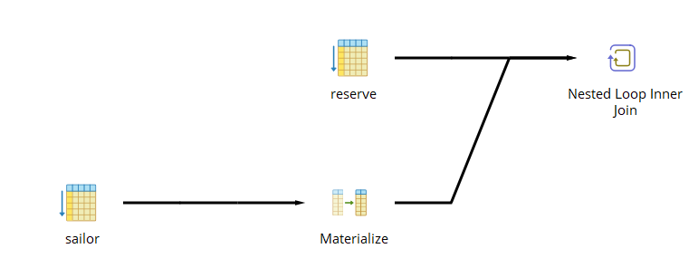

14.

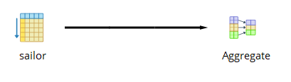

15.

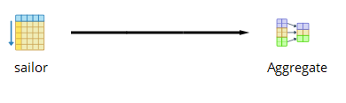

16.

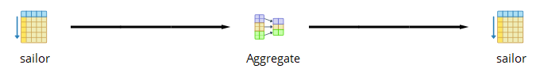17.

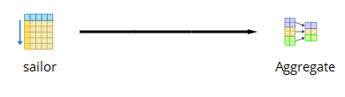

18.



19.



20.



D)

Below is the preposed indexing solution:

CREATE INDEX age

ON public.sailor USING btree

(age ASC NULLS LAST)

TABLESPACE pg_default;

ALTER TABLE public.sailor

CLUSTER ON age;

CREATE INDEX rate

ON public.sailor USING btree

(rating ASC NULLS LAST)

TABLESPACE pg_default;

ALTER TABLE public.sailor

CLUSTER ON rate;

CREATE INDEX sname

ON public.sailor USING btree

(sname COLLATE pg_catalog."C" varchar_ops ASC NULLS LAST)

TABLESPACE pg_default;

ALTER TABLE public.sailor

CLUSTER ON sname;

Below are the improved evaluation plans

1. No change

2. No change

3. Significant improvement, cost decreased due to elimination of sequential scan.

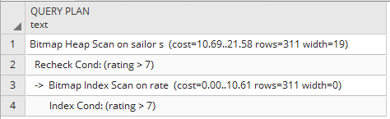

4.No change

5. No change

6. No change

7. No change

8. No change

9. Significant improvement, cost decreased due to elimination of sequential scan.

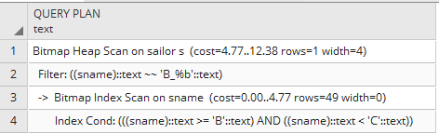

10. No change

12. No change

13. Significant cost decrease with the nested loop. Cost decrease due to the elimination of the sequential scan.

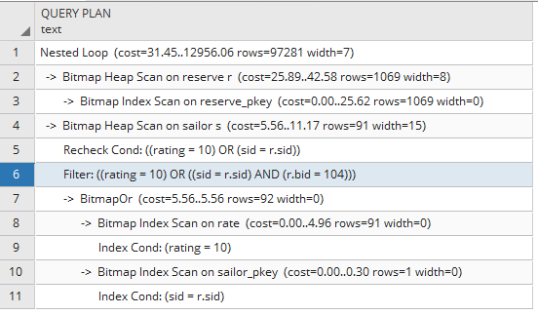

14. Significant improvement as elimination of the sequential scan greatly lowers total cost and cost of the aggregate.

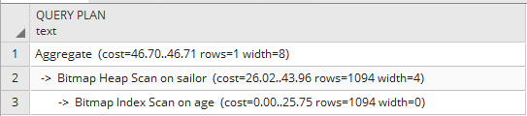

15. Significant improvement as elimination of the sequential scan greatly lowers total cost and cost of the aggregate.

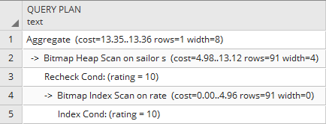

16. Significant improvement as eliminates the cost of the sequential scan.

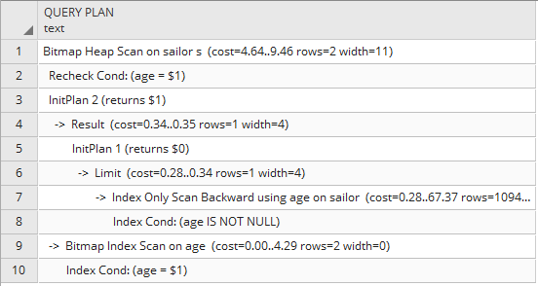

17. Significant improvement as elimination of the sequential scan greatly lowers total cost and cost of the aggregate.

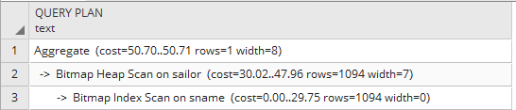

18. Significant improvement as elimination of the sequential scan greatly lowers total cost and cost of the aggregate.

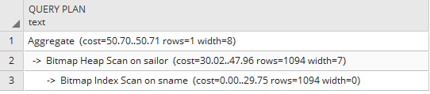

19. Significant improvement as elimination of the sequential scan greatly lowers total cost and cost of the GroupAggregate.

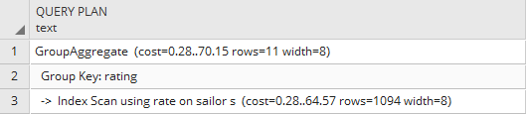

20. Significant improvement as eliminates the cost of the sequential scan.

